**Modern Design Experience**

**About the Modern Experience**

UiPath v2020.4 introduced the UiAutomationNext activities package that delivered a new way in which you identify, configure, and verify target UI elements with new activities, an all-in-one recorder, and a new data scraping wizard. Starting with v2020.10, the UIAutomationNext package has been deprecated and the existing UIAutomation package has been expanded to include all the modern features previously available in UiAutomationNext.

You can use the new features by making sure the [modern design experience is enabled](https://docs.uipath.com/studio/standalone/2023.10/user-guide/modern-design-experience) in your automation projects. Starting with Studio 2021.10, the modern design experience is enabled by default for all new projects. To find out what changes it brings, read about the [differences between modern experience and classic experience](https://docs.uipath.com/studio/standalone/2023.10/user-guide/modern-design-experience#differences-between-modern-experience-and-classic-experience).

A modern design experience is also available for Excel automation. For more information, see the [Activities guide](https://docs.uipath.com/activities/docs/about-the-excel-activities-pack#modern-design-experience-in-studio).

Please note that all projects created in the StudioX profile use the modern design experience by default.

**Enabling or Disabling the Modern Experience**

By default, the modern design experience is enabled for all new projects. If you want to use the **classic design experience** that includes the activities, wizards, and recorders that were available by default in Studio v2021.4 and older releases, disable the modern experience for specific projects or configure a global setting that makes it the default experience for all new projects. The project-level setting overrides the global setting.

* To enable or disable the modern experience for a project, in the **Project** panel, select **Project Settings**, then use the **Modern Design Experience** toggle from the **General** tab and reload the project.

**NOTE:** You can enable the modern experience for projects created in Studio versions prior to v2020.10, which use the classic experience by default.

This setting also enables / disables the modern design experience for Excel if the Excel Design Experience option is set to **UseGlobalSetting** in the Excel activities [project settings](https://docs.uipath.com/activities/docs/project-settings-excel).

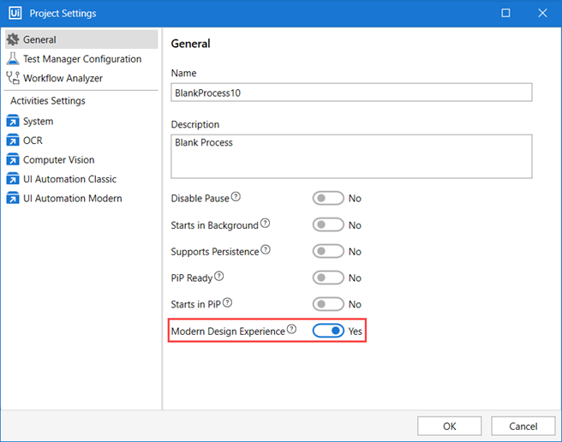

* To select the default experience for all **new projects**, go to **Home** (Studio Backstage View) > **Settings** > **Design**, and set the **Use Modern for new projects** toggle to enable or disable the **Modern Design Experience** project setting for all newly created projects.

**Differences Between Modern Experience and Classic Experience**

**Recorders**

* Modern experience - The [App/Web](https://docs.uipath.com/activities/docs/app-web-recorder) and [Computer Vision](https://docs.uipath.com/activities/docs/computer-vision-recorder)recorders are available.
* Classic experience - The [Basic, Desktop, Web, Image, Native Citrix](https://docs.uipath.com/studio/standalone/2023.10/user-guide/about-recording-types), and [Computer Vision](https://docs.uipath.com/activities/docs/computer-vision-recorder) recorders are available.

**Activities**

A separate set of activities is available by default in each experience.

Regardless of the experience selected for a project, you can also enable the activities that are only available by default in the other experience. Click **View Options** at the top of the **Activities** panel, and then select:

* **Show Modern** to view modern activities in a project that uses the classic experience
* **Show Classic** to view classic activities in a project that uses the modern experience.

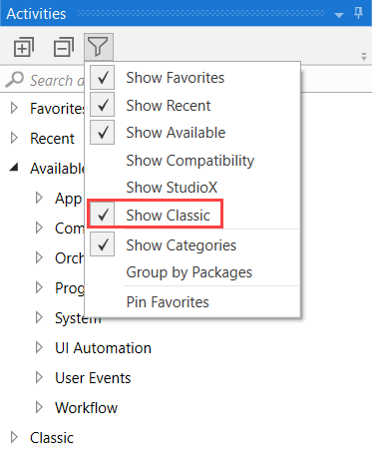

The following table lists the activities that are available by default in one experience but not in the other. The [UI Automation activities](https://docs.uipath.com/activities/docs/about-the-ui-automation-activities-pack) that are not listed in the table are available by default in both experiences.

| Modern Activities | Classic Activities |
| --- | --- |
| [Check App State](https://docs.uipath.com/activities/docs/n-check-state) | [On Element Appear](https://docs.uipath.com/activities/docs/on-ui-element-appear), [On Element Vanish](https://docs.uipath.com/activities/docs/on-ui-element-vanish), [On Image Appear](https://docs.uipath.com/activities/docs/on-image-appear), [On Image Vanish](https://docs.uipath.com/activities/docs/on-image-vanish), [Wait Element Vanish](https://docs.uipath.com/activities/docs/wait-ui-element-vanish), [Wait Image Vanish](https://docs.uipath.com/activities/docs/wait-image-vanish), [Find Image](https://docs.uipath.com/activities/docs/wait-image-appear), [Image Exists](https://docs.uipath.com/activities/docs/image-found), [Element Exists](https://docs.uipath.com/activities/docs/ui-element-exists) |
| [Check/Uncheck](https://docs.uipath.com/activities/docs/n-check) | [Check](https://docs.uipath.com/activities/docs/check) |
| [Click](https://docs.uipath.com/activities/docs/n-click) | [Click](https://docs.uipath.com/activities/docs/click), [Click Image](https://docs.uipath.com/activities/docs/click-image) |
| [Extract Table Data](https://docs.uipath.com/activities/docs/n-extract-data) | [Extract Structured Data](https://docs.uipath.com/activities/docs/extract-data), [Get Full Text](https://docs.uipath.com/activities/docs/get-full-text), [Get Visible Text](https://docs.uipath.com/activities/docs/get-visible-text) |
| [Get Text](https://docs.uipath.com/activities/docs/n-get-text) | [Get Text](https://docs.uipath.com/activities/docs/get-value) |
| [Go to URL](https://docs.uipath.com/activities/docs/n-go-to-url) | [Navigate To](https://docs.uipath.com/activities/docs/navigate-to) |
| [Highlight](https://docs.uipath.com/activities/docs/n-highlight) | [Highlight](https://docs.uipath.com/activities/docs/highlight) |
| [Hover](https://docs.uipath.com/activities/docs/n-hover) | [Hover](https://docs.uipath.com/activities/docs/hover), [Hover Image](https://docs.uipath.com/activities/docs/hover-image) |
| [Keyboard Shortcuts](https://docs.uipath.com/activities/docs/n-keyboard-shortcuts) | [Send Hotkey](https://docs.uipath.com/activities/docs/send-hotkey) |
| [Navigate Browser](https://docs.uipath.com/activities/docs/n-navigate-browser) | [Close Tab](https://docs.uipath.com/activities/docs/close-tab), [Go Back](https://docs.uipath.com/activities/docs/go-back), [Go Forward](https://docs.uipath.com/activities/docs/go-forward), [Go Home](https://docs.uipath.com/activities/docs/go-home), [Refresh Browser](https://docs.uipath.com/activities/docs/refresh-browser) |
| [Select Item](https://docs.uipath.com/activities/docs/n-select-item) | [Select Item](https://docs.uipath.com/activities/docs/select-item) |
| [Take Screenshot](https://docs.uipath.com/activities/docs/n-take-screenshot) | [Take Screenshot](https://docs.uipath.com/activities/docs/take-screenshot) |
| [Type Into](https://docs.uipath.com/activities/docs/n-type-into) | [Type Into](https://docs.uipath.com/activities/docs/type-into), [Type Secure Text](https://docs.uipath.com/activities/docs/type-secure-text) |
| [Use Application/Browser](https://docs.uipath.com/activities/docs/n-application-card) | [Open Application](https://docs.uipath.com/activities/docs/open-application), [Open Browser](https://docs.uipath.com/activities/docs/open-browser), [Attach Window](https://docs.uipath.com/activities/docs/window-scope), [Attach Browser](https://docs.uipath.com/activities/docs/browser-scope), [Element Scope](https://docs.uipath.com/activities/docs/element-scope), [Close Window](https://docs.uipath.com/activities/docs/close-window)  [Start Process](https://docs.uipath.com/activities/docs/start-process) |
| N/A | [Anchor Base](https://docs.uipath.com/activities/docs/anchor-base), [Context Aware Anchor](https://docs.uipath.com/activities/docs/anchor-context-aware) |

**Object Repository**

You can only use the [Object Repository](https://docs.uipath.com/studio/standalone/2023.10/user-guide/about-object-repository) in the modern experience with modern activities.

**Scraping Wizards**

* Modern experience - The **Table Extraction** wizard is available for data scraping.
* Classic experience - The **Data Scraping** and **Screen Scraping** wizards are available.

# About Object Repository

The **Object Repository** ensures the management, reusability, and reliability of UI elements by capturing them as objects in a DOM-like repository, sharable across projects. It allows for creating and reusing UI taxonomies inside and across automation projects. With Object Repository you can build a UI API for your application and share it with your team within minutes.

The key features of the **Object Repository** are:

* UI elements across the project are managed, updated, and modified from a centralized place.
* view a list of all your UI activities inside your process by using the UI Activities tab inside Object Repository panel.
* quickly capture elements you need in your automation with the **Capture Elements** wizard.
* increased selector reliability with the help of the **Capture Elements** recorder that captures elements, together with their anchors.
* with the help of anchors, objects keep their reliability in case the application received a slightly new UI.
* drag-and-drop elements from the **Object Repository** panel.
* objects are reusable in local project or across projects when packaged as libraries.
* upgrade application and process UI elements in one go with UI libraries.

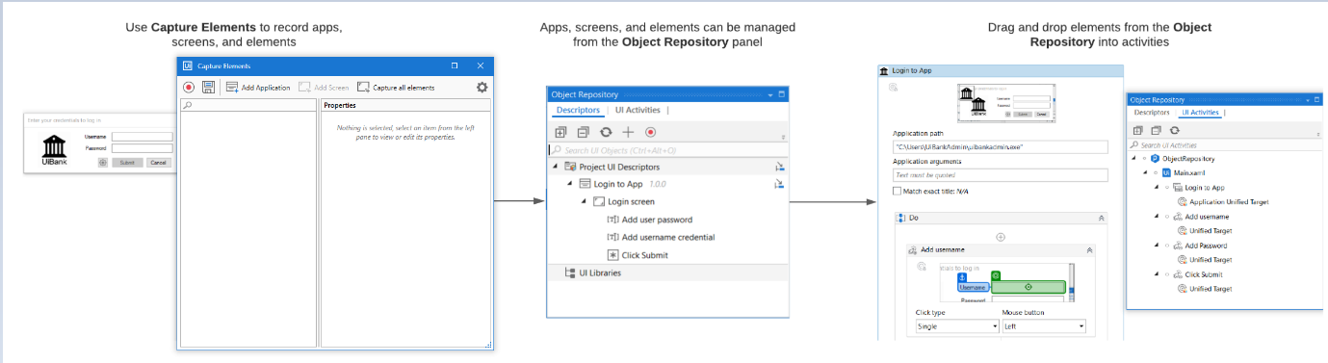

## Prerequisites

The **Object Repository** works with **UiPath.UIAutomation.Activities** package versions 20.10.x and above in projects that use the [Modern Design Experience](https://docs.uipath.com/studio/standalone/2023.10/user-guide/modern-design-experience). Note that **UiPath.UIAutomationNext.Activities** package has been deprecated as of 20.10. The activities from UI Automation Next are now found in the UI Automation package. The **Object Repository** is not available in cross-platform projects.

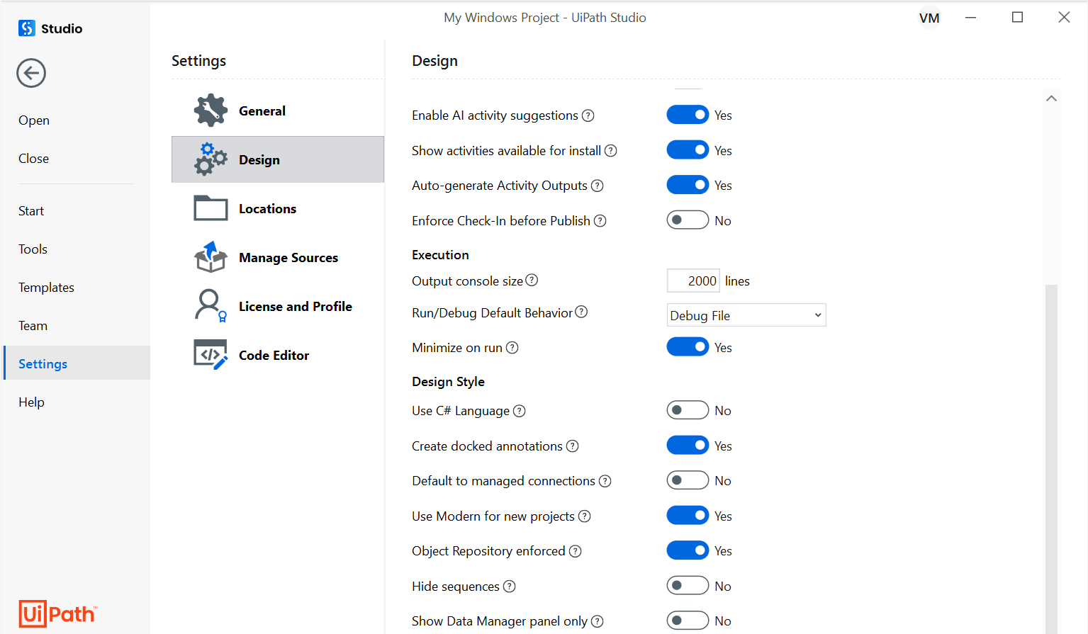

The **Use Modern for new projects** toggle controls the default design experience for new projects. Modern experience is a new way of designing automation with wizards, recorders, and activities part of the packs enhanced for Object Repository support. This toggle is on a global level, meaning that if enabled, all new projects are created within the context of modern design experience.

When the **Object Repository enforced** toggle is set to **Yes**, activities part of the UIAutomation pack need to reference elements from the Object Repository.

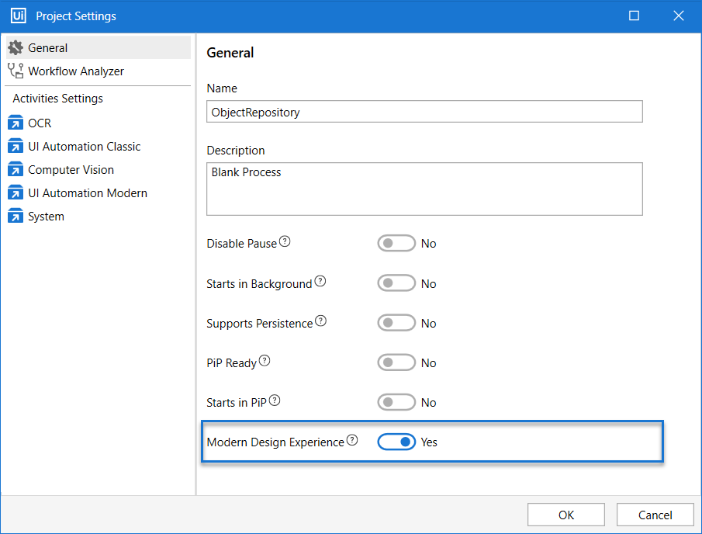

There is also a "Modern Experience" toggle at the project level. If enabled, the current project operates within the context of modern design experience. In a modern design experience, the classic UI Automation activities are hidden by default. They can be enabled by using the filters inside the Activities Panel. Alternatively, you can always switch to Classic Experience for a particular project from project settings. Or you can switch the behavior for new projects from the backstage Studio settings.

## Key Concepts

##### **UI Descriptors**

A UI Descriptor is a superset of selectors. It holds information for uniquely identifying elements on the screen.

UI Descriptors are extracted from activities in the workflow and added to a structured schema that groups them by Applications, Application Versions, Screens, and UI Elements. Out of this taxonomy structure, only Screens and Elements hold descriptor information. The rest are used for grouping and their role is to ensure upgrades between versions of an application.

UI Descriptors can be part of:

* one project for wide reuse.
* snippets repositories for testing purposes.
* UI Libraries for global cross-project sharing.

##### **UI Elements**

UI Elements contain full or partial element selectors, anchor selectors, screen and element image capture context, and other metadata that describes the element on the screen.

##### **Screens**

Screens are UI Scopes that are either extracted from activities inside the workflow or are generated at element capture time. A screen groups together multiple elements belonging to the same screen.

##### **UI Applications**

A UI Application is a targeted application that can have multiple versions and each version can have multiple screens. Applications can be of multiple types:

* Desktop / Web Application
* Mobile Application

For defining mobile applications, you need to use UiPath.MobileAutomation.Activities package.

The structure of UI libraries created with the Object Browser has the following hierarchy: **Application** > **Version** > **Screen** > **UI Element**.

##### **UI Libraries**

A UI Library is an encapsulation of elements grouped by applications, application versions, and screens. Elements you define can be extracted as a UI Library, and after publishing can be installed in other projects as a dependency.

A UI Library may contain several applications but can contain only one version of a certain application. This mechanism ensures that when you upgrade a dependency, you also upgrade the application version you were using inside your projects.

Note that when creating a new version of an existing application, you need to reuse the existing elements. Elements have unique identifiers that are used when referenced from activities. You can always change the contents of an element (descriptors and other metadata).

## Reusability

The **Object Repository** enables you to reuse your UI elements across projects:

* all locally stored elements can be reused at project level
* for testing purposes you can use **Snippets** panel to save into and pass applications between projects. From Snippets you can add applications to your local project repository.
* extract elements into UI libraries and install them as a dependency into your projects when you want to reuse at a global level. You can also take a reusability-first approach and start by creating UI Libraries with the elements you will need across all your automation projects.

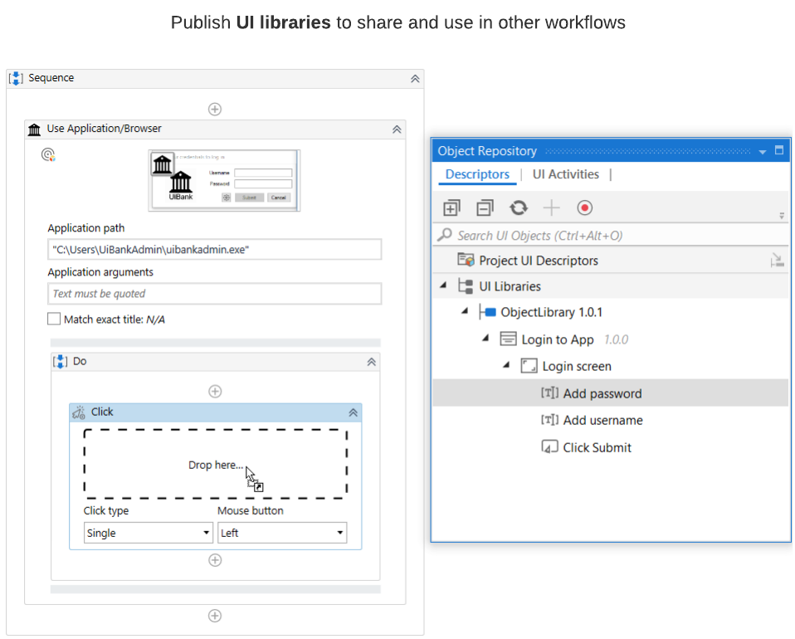

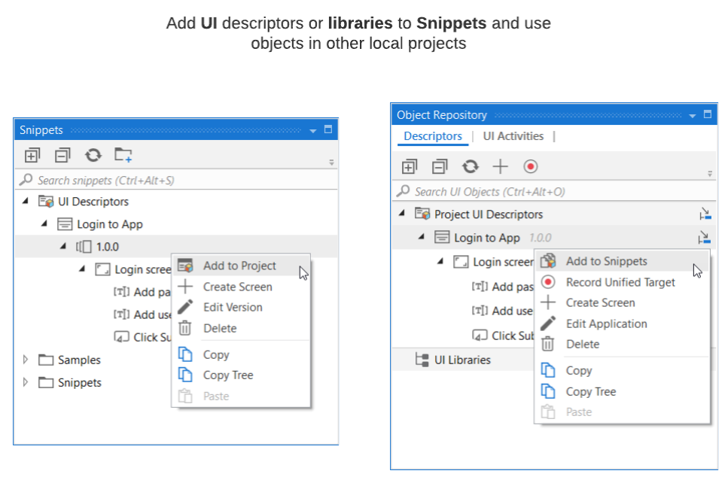

## Object Repository Structure

The object repository has a tree structure where each node is an object representing screens or elements, all hierarchical under the application. The structure is the following:

* Application - can be one of 2 types: mobile or desktop/web, depending on what technology is used for UI Automation.
* Version - applications can have multiple versions
* Screen - top-level window of an application version that can only be created under an app version.
* UI element - an object on the screen with a descriptor and metadata. It can be of multiple types.

UI elements can be freely rearranged in the tree structure, as long as they remain under their designated screen. To move, simply drag and drop the element to the desired location inside the tree.

Elements can also be part of other elements and they can also be grouped under containers with no UI specific role. This allows defining a UI structure that is as close as possible to what the user sees on screen.